**ARTIFICIAL INTELLIGENCE**

PROJECT REPORT

**TITLE: DEEP LEARNING MODEL FOR EYE DISEASES PREDICTION**

**TEAM MEMBERS:**

TEJASWINI VYAMSANI -20BCE0063

TADAPANENI SNEHITHA -20BCE0858

GOPA LAASYA LALITHA PRIYA -20BCE2255

BANDI HARSHAVARDHAN REDDY -20BCE2265

|  |  |  |
| --- | --- | --- |
| **Sl. No** | **Chapter** | **Page No** |
| 1 | Introduction | 4 |
| 2 | Literature Survey | 6 |
| 3 | Theoretical Analysis | 7 |
| 4 | Experimental Investigations | 8 |
| 5 | Result | 9 |
| 6 | Advantages and Disadvantages | 11 |
| 7 | Applications | 12 |
| 8 | Conclusion | 13 |
| 9 | Future Scope | 14 |
| 10 | Bibliography | 15 |
| 11 | Appendix | 16 |

**TABLE OF CONTENTS**

**LIST OF FIGURES**

|  |  |  |
| --- | --- | --- |
| **SI.No** | **Caption** | **Page No** |
| 1 | Block diagram for Eye Disease Prediction | 7 |
| 2 | Flowchart for Eye Disease Prediction | 8 |
| 3 | Home page | 9 |
| 4 | Images Page | 9 |
| 5 | Types of Eyes Page | 10 |
| 6 | Input Image and Predict | 10 |

1. **INTRODUCTION**

**1.1 Overview**

Our Project aims to develop a system or model that can accurately predict the occurrence or progression of various eye diseases based on specific indicators or risk factors. The project involves collecting relevant data, preprocessing and analysing it, selecting appropriate features, and building a predictive model using machine learning or deep learning algorithms.

The data used in the project typically includes patient demographics, medical history, visual test results, imaging data (e.g., retinal scans), and other relevant information. This data is cleaned, processed, and prepared for analysis. Feature selection or extraction techniques are applied to identify the most relevant features that can contribute to the prediction of eye diseases.

Once the features are selected, a suitable machine learning or deep learning algorithm is chosen to build the predictive model. The model is trained using a labelled dataset, where the occurrence or progression of eye diseases is known. Hyperparameters of the model are tuned to optimise its performance, and the model is evaluated using validation and test datasets.

After the model is trained and validated, it can be deployed into a production environment where it can be used for eye disease prediction. This can involve integrating the model into a web or mobile application, a healthcare system, or an electronic health record (EHR) system. The deployed model can provide predictions or risk assessments for individuals, enabling early detection and timely intervention for eye diseases.

**1.2 Purpose**

The purpose of our project is to address the need for accurate prediction and early detection of eye diseases. By developing an accurate and reliable predictive model, our project aims to contribute to the field of eye healthcare by enabling early detection and intervention for various eye diseases. We aim to improve patient outcomes and enhance vision health.

Early detection plays a crucial role in the treatment of eye diseases. Neglecting the root cause or symptom will add to the progression of conditions. Timely intervention can prevent or mitigate the development of the state. This will lead to better outcomes for patients. However, identifying early signs of eye diseases can be challenging, and many individuals may not realise until symptoms become obvious that indicate the disease has advanced.

Our project aims to overcome these challenges by leveraging deep learning algorithms to predict the occurrence of eye diseases. The predicting model we develop will enable healthcare professionals to assess an individual’s risk of developing specific eye diseases accurately. By integrating the model into web applications or mobile applications, our application can be accessible to a broader population and facilitate proactive eye care.

The ultimate goal of our project is to improve public health by reducing the burden of eye diseases and their associated complications. By enabling early detection, we can help individuals receive appropriate treatment and management plans, potentially preventing vision loss and enhancing their quality of life. Additionally, the project may contribute to the advancement of research in the field of eye healthcare and lead to further innovations in the prevention and treatment of eye diseases.

1. **LITERATURE SURVEY**

**2.1 Existing problem**

Researchers have explored the use of deep learning techniques to predict various eye diseases, including diabetic retinopathy, glaucoma, age related macular degeneration and retinopathy of prematurity among others.

But the most important existing problem of all is the limited availability and quality of data. Obtaining large and diverse datasets for training deep learning models can be challenging, hinder the development of accurate and generalizable prediction models.

Another problem is the lack of standardised protocols and data collection procedures across different healthcare institutions. Inconsistent data formats, variable imaging techniques, and varying quality of annotations can introduce noise and biases into the training process, affecting the model’s performance and reliability.

This will make the integration and adoption of the deep learning models into existing healthcare systems or clinical workflows complex. There is a need for seamless integration, interoperability, and compliance with data privacy and security regulations to ensure the smooth deployment and utilisation of these models in practice.

**2.2 Proposed solution**

To overcome the data acquisition we implemented data augmentation techniques to artificially increase the size and diversity of the available data. Techniques such as rotation, scaling, flipping, and adding noise to the images can help create additional training samples and enhance the model's ability to generalise across different variations.

We have Established strict quality assurance measures to ensure the reliability and accuracy of the collected data. This can involve thorough data cleaning processes, manual review of annotations, and validation. By enforcing high-quality standards, the noise and biases in the dataset can be minimised, leading to more robust and reliable deep learning models.

We are developing an application that can easily integrate and adapt the deep learning models into existing healthcare systems or clinical workflows.

1. **THEORETICAL ANALYSIS**

**3.1 Block diagram**

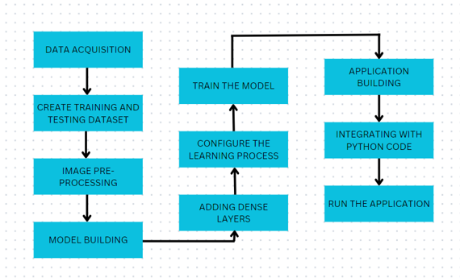

Fig.1.Block Diagram for Eye Disease Prediction

**3.2 Hardware / Software designing**

**3.2.1 Hardware requirements:**

GPU (used in Google Colab)

**3.2.2 Software requirements:**

Python libraries- NumPy, Pandas, Tensorflow, Keras

1. **EXPERIMENTAL INVESTIGATIONS**

While working on the eye disease prediction model, we used the VGG19 model and several experimental investigations were conducted to optimise and evaluate the performance of the model.

We have experimented with transfer learning by using the pre-trained model VGG19 model as a starting point. Fine-tune the model by retraining the last few layers using the eye disease dataset. Then we have evaluated the impact of transfer learning on model convergence, accuracy, and generalisation. We have obtained the same accuracy for the model without transfer learning.

We tried comparing the performance of the VGG19 model with other state-of-the-art deep learning architectures or traditional machine learning algorithms on the same eye disease dataset.

**4.1 FLOWCHART**

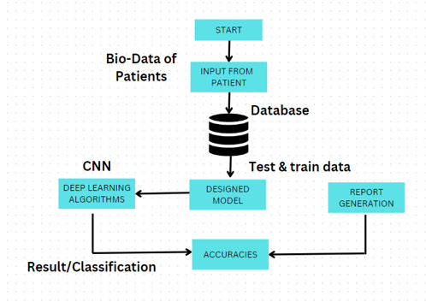

Fig.2. Flowchart for Eye Disease Prediction

1. **RESULT**

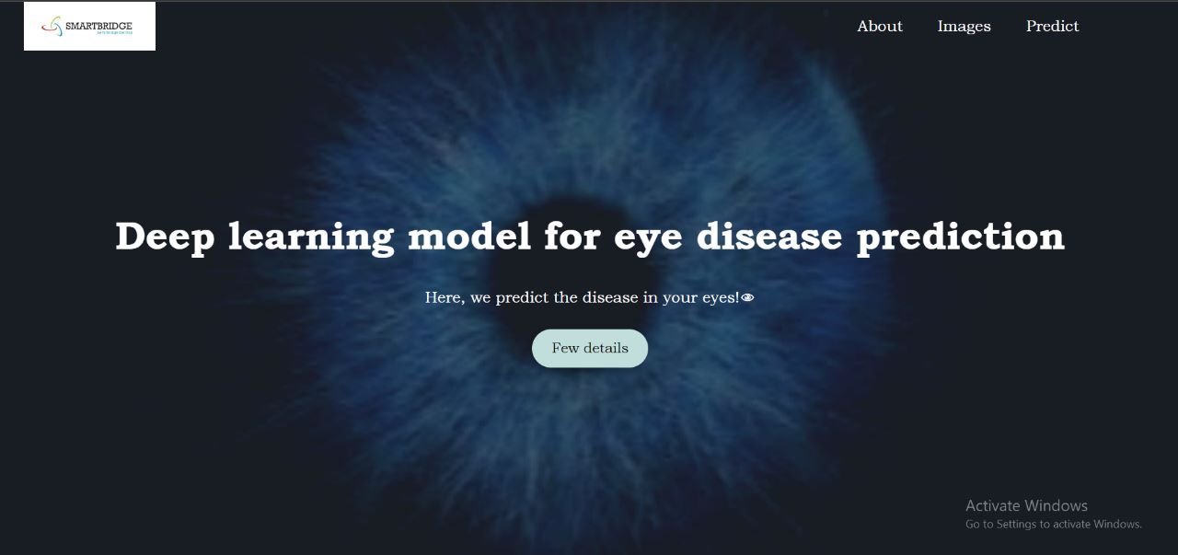

Fig.3. Home Page

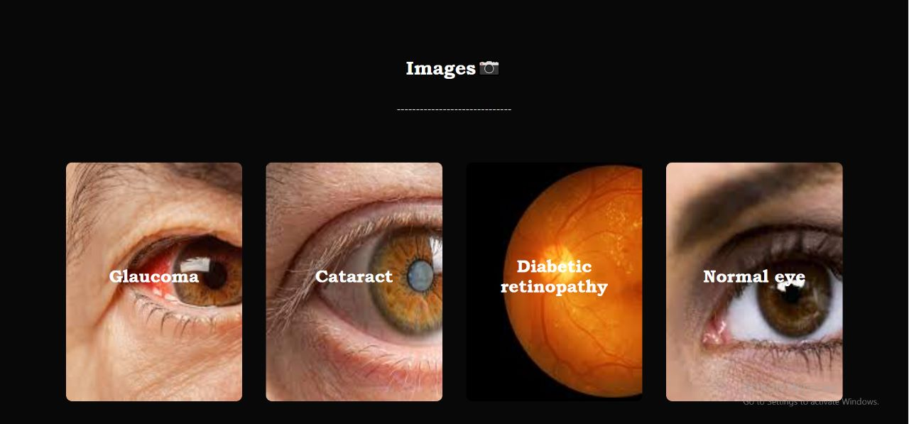

Fig.4.Images Page



Fig.5.Types of Eyes Page

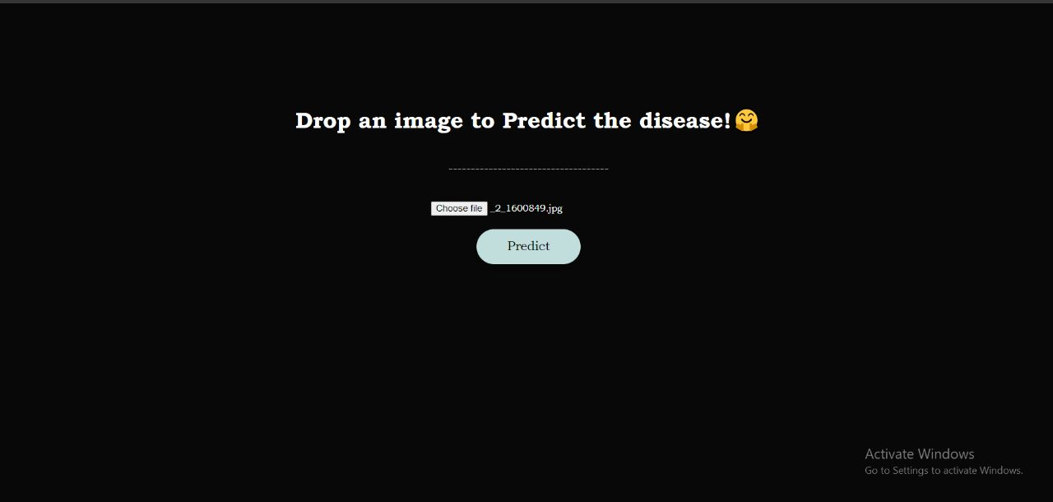

Fig.6. Input Image and predict

**5.3 Output**

1. **ADVANTAGES AND DISADVANTAGES**

**6.1 Advantages:**

1. Deep learning models have shown exceptional performance in various image recognition tasks, including eye disease prediction. They can learn complex patterns and features from large datasets, leading to high accuracy in disease detection.
2. Deep learning models can automatically learn relevant features from raw input data, eliminating the need for manual feature engineering. This ability allows them to discover subtle and intricate patterns that may not be easily discernible to human experts.
3. Deep learning models have the potential to generalise well to unseen data. Once trained on a diverse and representative dataset, they can identify eye disease patterns and make predictions on new and unseen images, facilitating early detection and intervention.
4. Deep learning models can scale effectively to handle large datasets and a wide range of eye diseases. As more data becomes available, the model can be retrained or fine-tuned to incorporate the new information, improving its performance over time.
5. Deep learning models can provide real-time predictions, enabling timely decision-making and intervention in clinical settings. This can be crucial in urgent cases or when immediate action is required to prevent disease progression.

**6.2 Disadvantages:**

1. Deep learning models often require large amounts of labelled data to achieve optimal performance. Collecting and annotating such datasets can be time-consuming, costly, and challenging, particularly for rare or complex eye diseases.
2. Deep learning models can be prone to overfitting, especially when the training dataset is small or imbalanced. Overfitting occurs when the model becomes overly specialised to the training data and fails to generalise well to new data. Regularisation techniques and careful validation are necessary to mitigate this issue.
3. Training and deploying deep learning models require substantial computational resources, including powerful GPUs or specialised hardware. This can limit the accessibility and scalability of the models, particularly in resource-constrained healthcare environments.
4. Deep learning models raise ethical considerations related to data privacy, bias, and equity. Ensuring proper data anonymization, addressing biases in the training data, and promoting fair representation of diverse populations are crucial to develop responsible and equitable eye disease prediction models.

**7. APPLICATIONS**

This domain has several potential applications in the field of healthcare and ophthalmology. Some of the key applications include:

1. Early Detection and Diagnosis: The prediction model can help in the early detection and diagnosis of various eye diseases such as glaucoma, macular degeneration, diabetic retinopathy, and cataracts. Early detection enables timely intervention and treatment, leading to better patient outcomes.
2. Personalized Treatment Planning: By accurately predicting the progression and severity of eye diseases, the model can assist in developing personalised treatment plans for individual patients. This can optimise treatment strategies and improve the effectiveness of interventions.
3. Screening Programs: Eye disease prediction models can be utilised in screening programs to identify individuals at high risk of developing specific eye conditions. This allows healthcare providers to prioritise resources and interventions for those who are most likely to benefit.
4. Telemedicine and Remote Monitoring: With the integration of eye disease prediction models into telemedicine platforms, patients can receive remote monitoring of their eye health. This facilitates timely detection of disease progression, reducing the need for frequent in-person visits and improving access to care.
5. Public Health Planning: Aggregated data from eye disease prediction projects can be used for public health planning and resource allocation. It helps in understanding the prevalence, distribution, and risk factors associated with different eye diseases, thus aiding in developing targeted public health interventions.
6. Research and Clinical Trials: Eye disease prediction projects generate valuable data that can contribute to ongoing research efforts and clinical trials. The insights gained from analysing this data can lead to advancements in the understanding and treatment of various eye conditions.

Overall, the applications of eye disease prediction projects have the potential to improve patient care, enhance disease management, and contribute to the broader field of ophthalmology.

**8. CONCLUSION**

In conclusion, the eye disease prediction model holds significant promise in the field of healthcare and ophthalmology. The development and implementation of accurate prediction models for various eye diseases offer numerous benefits and applications.

By enabling early detection and diagnosis, the project can help healthcare professionals intervene promptly, leading to improved patient outcomes. The personalised treatment planning made possible by accurate disease prediction allows for tailored interventions, optimising the effectiveness of treatments.

The integration of eye disease prediction models into screening programs enhances the identification of individuals at high risk, ensuring timely interventions and resource allocation. Additionally, the project's compatibility with telemedicine platforms enables remote monitoring, increasing access to care and reducing the need for frequent in-person visits.

The aggregated data from these prediction projects also contributes to public health planning, research endeavours, and clinical trials. The insights gained from analysing this data can lead to a better understanding of eye diseases, their prevalence, and associated risk factors, ultimately aiding in the development of targeted interventions.

**9. FUTURE SCOPE**

Future advancements in machine learning algorithms and data analysis techniques are likely to enhance the accuracy of eye disease prediction models. As more data becomes available, models can be trained on larger and more diverse datasets, leading to improved prediction capabilities.

Integration with wearable devices: The integration of eye disease prediction models with wearable devices such as smart glasses or contact lenses holds great potential. These devices can continuously monitor various ocular parameters, including intraocular pressure, tear film composition, and blood flow, among others. By analysing real-time data, predictive models can provide timely alerts and personalised recommendations for individuals, allowing for proactive management of eye health.

It is important to note that the implementation of any predictive model in a clinical setting requires rigorous validation and adherence to ethical guidelines to ensure patient safety and privacy. Nonetheless, the future scope of eye disease prediction projects appears promising and holds great potential for improving eye care and preventing vision loss.

**10.BIBLIOGRAPHY**

[1] Malik S, Kanwal N, Asghar MN, Sadiq MA, Karamat I, Fleury M. Data driven approach for eye disease classification with machine learning. Applied Sciences. 2019 Jul 11;9(14):2789.

[2] Grassmann F, Mengelkamp J, Brandl C, Harsch S, Zimmermann ME, Linkohr B, Peters A, Heid IM, Palm C, Weber BH. A deep learning algorithm for prediction of age-related eye disease study severity scale for age-related macular degeneration from color fundus photography. Ophthalmology. 2018 Sep 1;125(9):1410-20.

[3] Shamsan A, Senan EM, Shatnawi HS. Automatic Classification of Colour Fundus Images for Prediction Eye Disease Types Based on Hybrid Features. Diagnostics. 2023 May 11;13(10):1706.

[4] https://www.kaggle.com/datasets/kondwani/eye-disease-dataset

[5] Consugar MB, Navarro-Gomez D, Place EM, Bujakowska KM, Sousa ME, Fonseca-Kelly ZD, Taub DG, Janessian M, Wang DY, Au ED, Sims KB. Panel-based genetic diagnostic testing for inherited eye diseases is highly accurate and reproducible, and more sensitive for variant detection, than exome sequencing. Genetics in Medicine. 2015 Apr;17(4):253-61.

**APPENDIX**

**A. Source Code**